|  |
| --- |
|  |
| 新概念 3 册 |
| Lesson6 **smash-and-grab** |

参考

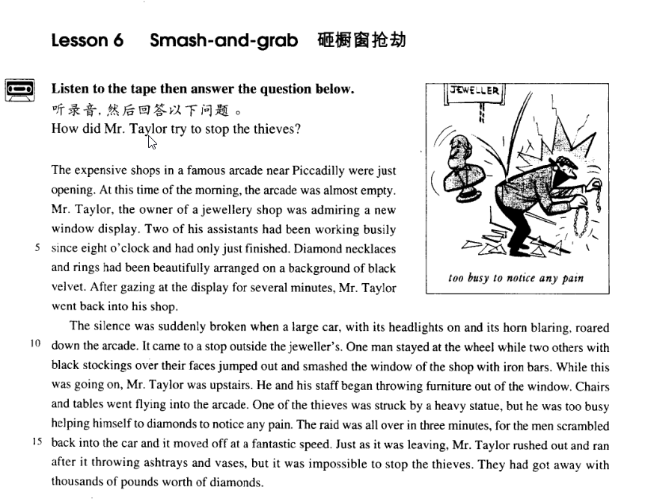

课文

**LESSON 6 smash-and-grab**

The expensive shops in a famous arcade near Piccadilly were just opening.

At this time of the morning, the arcade was almost empty.

Mr. Taylor, the owner of a jewellery shop was admiring a new window display.

Two of his assistants had been working busily since 8 o'clock and had only just finished.

Diamond necklaces and rings had been beautifully arranged on a background of black velvet.

After gazing at the display for several minutes, Mr. Taylor went back into his shop.

The silence was suddenly broken when a large car, with its headlights on and its horn blaring, roared down the arcade.

It came to a stop outside the jeweller's.

One man stayed at the wheel while two others with black stockings over their faces jumped out and smashed the window of the shop with iron bars.

While this was going on, Mr. Taylor was upstairs.

He and his staff began throwing furniture out of the window. Chairs and tables went flying into the arcade.

One of the thieves was struck by a heavy statue, but he was too busy helping himself to diamonds to notice any pain.

The raid was all over in three minutes, for the men scrambled back into the car and it moved off at a fantastic speed.

Just as it was leaving, Mr. Taylor rushed out and ran after it throwing ashtrays and vases, but it was impossible to stop the thieves.

They had got away with thousands of pounds worth of diamonds.

How did Mr. Taylor try to stop the thieves?

皮卡迪利大街附近的一条著名拱廊街道上，几家高档商店刚刚开始营业。

在早晨的这个时候，拱廊街上几乎空无一人。

珠宝店主泰勒先生正在欣赏新布置的橱窗。

他手下两名店员从早上8点就开始忙碌，这时刚刚布置完毕。

钻石项链、戒指漂亮地陈列在黑色丝绒上面。

泰勒先生站在橱窗外凝神欣赏了几分钟就回到了店里。

宁静突然被打破，一辆大轿车亮着前灯，响着喇叭，呼啸着冲进了拱廊街，

在珠宝店门口停了下来。

一人留在驾驶座上，另外两个用黑色长筒丝袜蒙面的人跳下车来。他们用铁棒把商店橱窗的玻璃砸碎。

这开始发生时，泰勒先生正在楼上。

他与店员动手向窗外投掷家具，椅子，桌子飞落花流水在拱廊街上。

一个窃贼被一尊很重的雕像击中，但由于他忙着抢钻石首饰，竟连疼痛都顾不上了。

这场抢劫只持续了3分钟，因为窃贼争先恐后地爬上轿车，以惊人的速度开跑了。

就在轿车离开的时候，泰勒先生从店里冲了出来，跟在车后追赶，一边还往车上扔烟灰缸、花瓶。但他已无法抓住那些窃贼了。

他们已带着价值数千镑的首饰逃之夭夭了。

泰勒先生如何试图阻止小偷？

词汇

* **smash-and-grab** [smæʃ-ən-'ɡræb] n. 砸橱窗抢劫

**smash-and-grab** n. a kind of robbery in which the robbers break the shop window and steal the goods on display

**smash** 粉碎

* smash the window
* The glass smashed into small bits.
* We’re determined to smash terrorism.
* sm**ash** the Gang of Four

**shatter** v. 毁坏

* shatter the window
* 歌词：

The glass shattered into small bits. When I’m in your arms

Nothing seems to matter

My whole world could **shatter** I don’t care

—Phil Collins

**shatter one’s dream / hope / confidence …** 打碎某人的….

* Peter’s comments shattered the boy’s confidence. 打碎信心

**grab** vt. 强夺

* A mugger **grabbed** her handbag as she was walking across the park.

**seize**

* As the men refused to stop working, the police attempted to **seize** the pneumatic drill.
* **jewellery / jewelry** ['dʒu:əlri] n. 珠宝（总称，不可数）
* a piece of jewelry
* two pieces of jewelry
* She has a lot of beautiful jewelries. X 错误，不可数
* She has a lot of beautiful jewelry. √
* She has a lot of beautiful jewels. √

**可数** **不可数** **解释**

jewel jewelry / jewellery 珠宝

scene scenery 景象

machine machinery 机器

weapon weaponry 武器

poem poetry 诗歌

novel fiction 消息

myth mythology 神话

leaf foliage 树叶

table / chair … furniture 家具

pen / pencil … stationery 文具

trunk / suitcase … luggage / baggage 行李

* **staff** [stɑ:f] / [stæf] n. 全体工作人员
* The hospital’s medical **staff** is / are excellent. （谓语动词单数复数都行）

**teaching staff**  全体老师

**engineering staff**  全体工程师

**domestic staff**  全体佣人

* Though my aunt pursued what was, in those days, an enlightened policy, in that she never allowed her **domestic staff** to work more than eight hours a day, she was extremely difficult to please.
* Already, orientals and Asian Americans constitute the majority of the **engineering staffs** at many Valley firms.

**整体名词**

staff

cast 全体演员

crew 全体船员

faculty 全体教师

audience 全体观众

课文

* **英语记叙文 (narrative) 的要点**

1：**五个W 一个 R (when, where, who, why, what and result)**

**2：目的明确，线索清晰，描写生动，详略得当，句式多变。**

* **课文讲解**

# The expensive shops in a famous arcade near Piccadilly were just opening.

**expensive shops / hotels**

* Mary is an **expensive** girl. She eats like a horse.

**表达“高档，豪华”**

a **fancy / luxury** car

a **fancy / luxury** hotel

**arc 词根，和“弧形”相关**

**arcade**

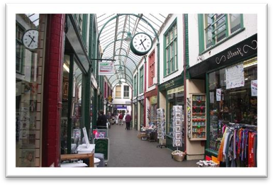

**17-Arch Bridge** 十七孔桥

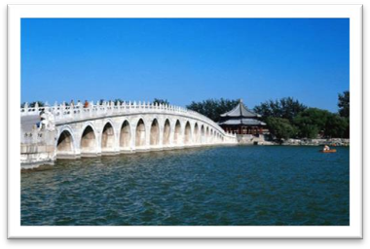

**Arch of Triumph** 凯旋门

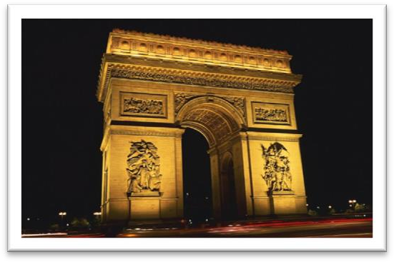

* The student hid in an archway nearby where he could watch and hear everything that went on.

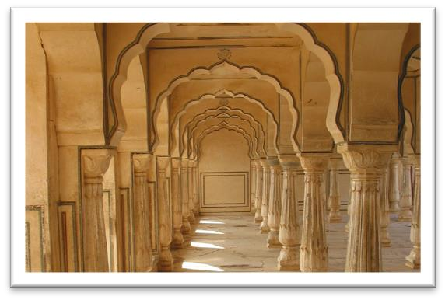**Archway**

**表示“在附近”：**

**around …**

**close to …**

**in the neighborhood of …**

**in the vicinity of …**

**off …**

* I rent an apartment **off** campus. 在校园附近
* 托福**听力：**

A. She needs help finding a place to live.

B. There aren't enough rooms available in the dormitories.

C. She can't afford to live on campus.

D. She doesn't want to live in university housing.

对话：

M: Will you be living in the dormitory this year?

W: Not if I can help it. I've been thinking of renting an apartment off campus with some friends of mine.

问题：

Q: What does the woman imply?

答案：

Answer: (D) She doesn't want to live in university housing.

**Piccadilly *n.*** 皮卡迪利大街（伦敦的繁华街道）

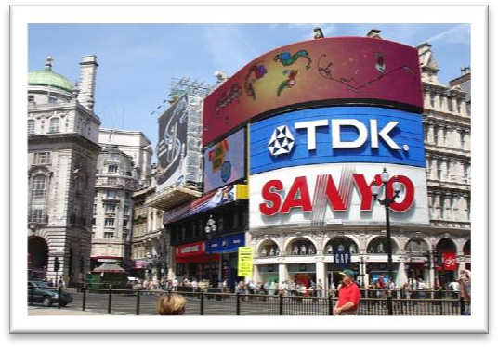

* 造句: 在朝阳区建国门外大街上高档的国贸商城 (China World Shopping Mall) 刚刚开始营业。

The expensive China World Shopping Mall on / at the JianGuoMenWai Avenue in Chaoyang District was just opening. （地点从小到大）

# At this time of the morning, the arcade was almost empty.

**empty 表达“空荡荡的”：**

* empty an empty truck
* empty streets

# Mr. Taylor, the owner of a jewellery shop was admiring a new window display.

**表示“店铺“的属格，必须是职业身份：**

the jeweler's 珠宝店

the grocer's 杂货店

the tailor's 裁缝铺

the baker's 面包房

the butcher's 肉铺

the barber's 理发店

the stationer's 文具店

the chemist's 药铺

**在人后面加属格不一定代表店铺：**

* We spent the weekend at **Mr. Green's (house)**.
* He graduated from **St. John's (University)**.
* Joe lives near **St. Paul's (Cathedral)** in London.

**admire表“钦佩“不能用进行时：**

* I admire her courage.

**admire表“欣赏“：**

* I am admiring her beauty. 正在欣赏

**gaze at …** 表示出神的看

* After **gazing at** the display for several minutes, Mr. Taylor went back into his shop.

# Two of his assistants had been working busily since 8 o'clock and had only just finished.

**售货员 [英]**

an assistant manager

(shop) assistant

**售货员 [美]**

(shop) clerk

**语法:过去完成进行时:** 表示持续性的动作一直做到过去的某时，而且还有可能继续下去。

**had been doing**

* Bleriot **had been making** planes since 1905 and this was his latest model.
* The small ship, Elkor, which **had been searching** the Barents Sea for weeks, was on its way home. The Karen had been sailing in a convoy to Russia when she was torpedoed by an enemy submarine.
* People woken during these periods of eye-movements generally reported that they **had been dreaming**.

**only just** adv. not long ago / before 刚刚

* We've **only just** arrived.
* I've **only just** moved to London.
* People were leaving and I'd **only just** arrived.

# Diamond necklaces and rings had been beautifully arranged on a background of black velvet.

**arrange *vt.*** 安排；排列；整理

* We arranged the chairs in a semicircle.
* His books are neatly arranged in alphabetical order.

# After gazing at the display for several minutes, Mr. Taylor went back into his shop.

**gazed at** 充满兴趣的看/看的出神

**stared at** 凝视

**gaped at** 看傻了

**glared at** 怒目而视

* He gazed at the belle.
* He stared at the belle.
* He gaped at the belle.
* The belle glared at him.

写好文章的精髓:

文似看山不喜平。

为人贵直,而作诗文者贵曲。

— 袁枚《随园诗话》

下文转折

# The silence was suddenly broken when a large car, *with its headlights on and its horn blaring*, roared down the arcade.

**语法: 独立主格**

**(with) + n. (逻辑主语)+ 非谓语 (doing / done / to do, 其中 being 常省略), 在句中常作状语或定语**

* The silence was suddenly broken when a large car, **with its headlights(逻辑主语) *(being) on* and its horn *blaring*,(整句做伴随状语)** roared down the arcade.
* One man stayed at the wheel while two others ***with black stockings (being) over their faces***jumped out and smashed the window of the shop with iron bars.
* …, and at this point, according to my father, I should be looking at farms and cottages in a valley, ***with the spire of the church of our village（后置定语） showing in the far distance.***
* It is possible that upon such an occasion a battle ensued, **with the sharks *being driven away or killed*.（结果状语）**
* Apart from an interesting-looking carved dagger, the box was full of crockery, **much of it *broken*. *（后置定语）***
* In the nineteenth century, a novelist would bring his story to a conclusion by presenting his readers with a series of coincidences—***most of them wildly improbable. （后置定语）***
* The village seemed deserted, **the only sign of life *being an ugly-looking black goat tied to a tree on a short length of rope in a field nearby*.（定语或状语）**
* it is quite reasonable to regard the sea floor as the basic form of the crust of the earth, **with, *superimposed upon it*, the continents, together with the islands and other features of the oceans. *（定语）***
* （上一句的正常语序）it is quite reasonable to regard the sea floor as the basic form of the crust of the earth, with the continents, together with the islands and other features of the oceans *superimposed upon it*. ***（定语）***
* Collecting, by occupying spare time so constructively, makes a person contented, with no time*(being) for boredom*.

独立主格和非谓语动词一样，一般是为了突出句中的次要信息

He came in and carried a book.

He came in carrying a book.

He came in and a book was in his hand.

He came in (with) a book (being) in his hand.

**roared**

The of airplane engines announced a coming air raid.

A. roar 咆哮

B. exclamation 惊叫

C. whistle 轻声

D. scream 尖叫

* **造句：**宁静突然被打破，一个凶恶的家伙(a tough guy)，瞪着眼睛拿着枪，闯进了(break into)银行。

The silence was suddenly broken when a tough guy, with his eyes glaring and a gun in his hand, broke into the bank.

# It came to a stop outside the jeweller's.

**come to a stop / halt = stop / halt** 停止，终止

* Bruce **charged**（冲刺） at it, but in the middle, the car **came to a grinding halt**.（戛然而止）

**come to an end = end** 结束

**come to a close = close** 结束

**come to a decision = decide** 做出决定

**come to a conclusion = conclude** 得出结论

# One man stayed at the wheel while two others with black stocking over their faces jumped out and smashed the window of the shop with iron bars.

**at the wheel** 在驾驶室里

**while / whereas** 而

* He must be over 60, while / whereas his wife looks about 30.

**while 表“尽管，即使”，在句首引导让步状语从句**

* **While** she is a likable girl**,** she can be extremely difficult to work with.
* **While** they enjoy the comfort and banal luxury of their dwelling, they do not realize that they are deprived of the necessities of life.
* **While** the quality of legal journalism varies greatly, there is an undue reliance amongst many journalists on interpretations supplied to them by lawyers.
* **While** comment and reaction from lawyers may enhance stories, it is preferable for journalists to rely on their own notions of significance and make their own judgments.
* **While** Washington and Jefferson privately expressed distaste for slavery, they also understood that it was part of the political and economic bedrock of the country they helped to create.

# While this was going on, Mr. Taylor was upstairs.

**表“与此同时”**

**at the same time**

**meanwhile**

**(in the) meantime**

# He and his staff began throwing furniture out of the window.

**主动发出的行为用doing**

**客观发生的to do**

* Many of the tourists on board had begun **bargaining** with the tradesmen, ……
* It began **to** rain.
* During the journey, the boat began **to** sink.

# Chairs and tables went flying into the arcade.

**flying** 此处做非谓语，此处做方式状语

* The boy went **running** to meet him. （方式状语）
* The girl came **bouncing** to tell me the news. （方式状语）

# One of the thieves was struck by a heavy statue, but he was too busy helping himself to diamonds to notice any pain.

**be busy doing sth. / be busy with sth.** 忙于做某事

* They are **busy preparing for** the wedding.
* They are **busy with preparations for** the wedding.

**be too busy doing sth. to do sth.** 太忙做某事….而忘了做某事…

* He was **too busy working to** notice us come in.

**be up to one’s neck / ears / eyes in …** 表示非常忙碌，忙于某事

* He is up to his ears in work.

**听力真题**

A. She wants to check the weather before deciding.

B. She has a problem with her hearing.

C. She’d enjoy coming to dinner another time.

D. She wants the man to help her with some work.

原文：

M: Can you come over for dinner tonight?

W: I’**m up to my ears in work**, so I’ll have to **take a rain check**. (改日)

问题：

Q: What does the woman mean?

回答：

Answer: (C) She’d enjoy coming to dinner another time.

**表“**忙于某事**”**

**be wrapped up in …**

**be absorbed in …**

**be immersed in …**

* He is totally **immersed in** the novel.
* In the new country he **became absorbed in** making a new life for the two of us, so that he gradually ceased to grieve.

**help oneself to sth. 表“**自己做某事。。。”

* **Help yourself to** a beer.

**help oneself to sth. 表“偷，抢**”

* They **helped themselves to** the farmer’s apples.
* The birds covered the distance in three minutes.

# The raid was all over in three minutes, for the men scrambled back into the car and it moved off at a fantastic speed.

**in** three minutes 花费了3分中

**within** three minutes 3分钟之内

**under** three minutes 不超过3分钟

**scrambled** 仓皇的跑

* As the burning plane landed, the terrified passengers **scrambled** for the door.

**speed** 介词搭配，做不可数名词时，与 at, with 搭配均可

* at / with great **speed**

**speed** 做可数名词时，只能与 at 搭配

* at **a speed** of 60 mph

# Just as it was leaving, Mr. Taylor rushed out and ran after it throwing ashtrays and vases, but it was impossible to stop the thieves.

表“追，追求”

**run after**

**chase**

**pursue**

* Instead of studying, he wastes his time **chasing** girls.
* The thief ran across the field, with an officer **pursuing** him.

**possible，impossible 这类词主语不能是人**

# They had got away with thousands of pounds worth of diamonds.

**金钱 + worth of + 物品** 价值多少钱的东西

* one billion dollars worth of merchandise
* fifty pence worth of trouble
* 美剧对话

Ross: Well, how was the date?

Rachel: Well I’m alone and I just bought **fifteen dollars worth of** candy bars, what do you think?

* I just bought **50 yuan worth of** groceries.